A11G Board Bringup (S24)

A **group** submission to be submitted on Github Classroom & Gradescope.

**Github Classroom assignment:** <https://classroom.github.com/a/U-8Xix3F>

Remember to read the [ESE5160 S24 Assignment README](https://docs.google.com/document/d/1pPXQByy8eTxTJ--3vO8KpTjMk5yBHF8wQXoLJ55w5a8/edit) before starting!

If you need to use a late day, you must submit using [this form](https://docs.google.com/forms/d/e/1FAIpQLSd2hfFc7tIAqP-B1GouC5sP6Zbl59p7JXJa_yGTR60CJHRU3A/viewform).

# Table of Contents

**Table of Contents 1**

**Learning Objectives 2**

**Assignment Overview 2**

**0. Safety & Mise En Place 2**

**1. Visual Board Inspection & Photograph 2**

**2. Power System Evaluation 3**

2.1 Distinct Power Modes 3

Example: Distinct Power Modes 3

2.2 Power Regulation Evaluation 3

Simulating a Full LiPo Power Supply 4

Example of Power System Evaluation Submission 5

2.3 Load Testing 7

Example Load Testing 7

2.4 Thermal Image 8

**3. Programming 9**

**4. Peripheral Evaluation 10**

4.1 Debug LED 10

4.2 Debug Button 10

4.3 UART Communication 10

4.4 Non-volatile Memory (SD Card) 10

4.5 I2C Device 10

**Rubric 11**

# 

# Learning Objectives

# Assignment Overview

Receiving printed circuit board assemblies is an exciting and stressful time! How can you determine if your carefully designed PCBA actually works how you intended it to? The objective of this assignment is to bring you through a thoughtful bringup process, hopefully avoiding any costly mistakes. By the end of this assignment, you will have tested all critical functionality of your PCBA. You’ll be able to power up and write firmware to your custom board.

The companion lecture PDF is **L22 Board Bringup**. Keep handy the [Detkin Lab Resource webpage](https://detkin.ese.upenn.edu/resources/parts/) and [tutorials page](https://detkin.ese.upenn.edu/tutorials/) for help with the equipment (oscilloscope, power supply, digital multimeter, etc.)!

# 0. Safety & Mise En Place

Before even touching your PCBA, get your station in order. [Mise en place](https://en.wikipedia.org/wiki/Mise_en_place) is a term used in the culinary world to describe getting your physical and mental self prepared for the job at hand. As such, please complete the following before moving forward:

1. Find and clean your station within the Detkin Lab.
   1. Your station must have a DC power supply and oscilloscope.
2. Read this assignment in full to understand what we’re doing today.
3. Review where all equipment and supplies live that you’ll need.
4. Obtain [ESD straps](https://www.bondline.co.uk/blog/how-does-an-anti-static-wristband-work#:~:text=ESD%20wrist%20straps%20are%20the,a%20person%20safely%20to%20ground.) for protection while working with the bare PCBAs.
5. Get anything else you think you’ll need to complete the assignment.
6. Get your PCBAs from the teaching team.

# 1. Visual Board Inspection & Photograph

While connected to your ESD strap, open your PCBA from its protective packaging. Keep the protective ESD dissipative packaging - you should be using it when transporting the PCBA from one place to the other or when storing it in your plastic containers. Open Altium on your laptop and go to PCBA 3D mode. Select the manufacturing variant, which will show which components are populated. Ask yourself these questions as a starting point:

* Does your PCBA look like the 3D model?
* Are any components soldered to the board that shouldn’t be?
* Do you see any manufacturing errors, like solder bridging, rotated components, or poor workmanship?

Microscopes are available in the lab if you need to get a closer look at anything. Write down anything that seems suspicious - and ask the teaching team for help as well.

After completing the optical inspection, take your PCBA to the light box in Detkin lab. Take at least three photos highlighting different sides and angles of the PCBA (Shopify has a [nice guide](https://www.shopify.com/blog/15163633-how-to-capture-high-quality-product-photos-with-your-smartphone) if you want to learn more).

**Submission:**

* List any issues uncovered in optical inspection.
* Submit at least three light box photos of your PCBA.

# 2. Power System Evaluation

In this section, we’ll take a measured approach to testing our voltage regulators designed into our PCBA.

### 2.1 Distinct Power Modes

Write a list of distinct power modes / conditions in your system. What regulated and unregulated voltages do you have in your system? What different modes can each of your ICs be in? (Hint: what happens when you apply USB power?)

When evaluating your PCBA, you should evaluate all of these power modes to ensure correct operation. In this assignment, you will evaluate your highest risk power regulator in great detail, while only doing basic evaluation of your other regulators.

#### Example: Distinct Power Modes

My device has two power sources: single cell LiPo and USB power. It has one regulator: a 3.3V buck. My distinct power modes would be:

1. Unregulated battery only is connected and ranges from 3.30V to 4.20V
2. Regulated USB only is connected and ranges from 4.85V to 5.25V
3. Both battery and USB are connected, so the USB voltage will be preferred (4.85-5.25V)

**Submission:** Submit a list of your distinct power modes within your PCBA.

### 2.2 Power Regulation Evaluation

We want to determine how well (if at all!) the PCBA power regulation circuitry is working. We’ll leverage the oscilloscopes in the lab to capture various critical modes. Key questions we’ll be answering in this section are:

* **Are there any critical failures (i.e shorting, over voltage, etc.)?**
* **Are we generating the voltage we expected?**
* **Is the ripple on the output acceptable?**

Before starting, disconnect the voltage regulation IC input and output jumper resistors. See the desoldering jumpers video in the assignment folder to learn how to do this with the soldering iron. Then, connect ONLY the input jumper to the first voltage regulator under test (do NOT the output jumper!). You will repeat these steps for each of the regulators in your circuit until all have been validated.

Next, solder **24 AWG** **stranded** wires to the voltage test points on your PCBA required for this section. Stranded, thinner wires are better at this point because they will exert less force on your PCB pads. You don’t want to rip the pads from the surface of the PCB! You can use Kapton tape to affix the wires to the PCB surface to provide strain relief as well.

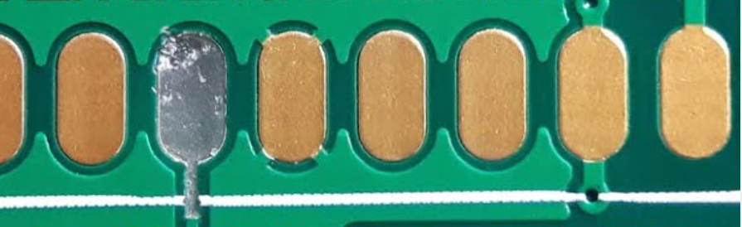

You will only measure your voltages within one power mode: a simulated full LiPo battery. You will simulate a full LiPo battery attached to the system using a current limited power supply is attached to the Vsystem output from the BQ24075. See the image and instructions below:

#### Simulating a Full LiPo Power Supply

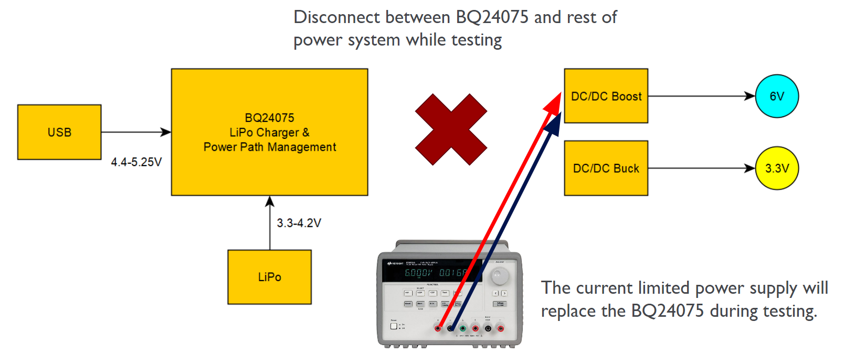

1. Adjust your power supply to the input voltage you’d like to evaluate: 4.2V for a fully charged LiPo battery.
2. Set the current limit to 10mA at the start.
3. Ensure that the voltage output is off, then attach the power supply output to the stranded wires you soldered to your PCBA.
4. Turn on your power supply.
   1. It will likely hit the current limit - the power supply will have some indication of **CC** for **constant current**. This means the voltage is limited - the current limit isn’t high enough!
   2. Increase the current limit until the power supply is in **CV** mode, for **constant voltage**.
   3. **Beware of shorts!** If your circuit is shorted, the power supply will always enter CC mode. This is where you need to use your engineering knowledge - what is a reasonable current that my power regulator should need to overcome the transient current spike to enter steady state? Hint: It’s probably not going to be 1000mA!
      1. If you hit the CC mode unexpectedly, turn off the power supply immediately and ask the teaching team for help. You can save your PCBA by having quick reflexes here and thinking clearly.

Once your power regulator turns on properly, we can start to profile its performance. For each of your power regulation circuits, provide:

1. An oscilloscope capture of the **startup transient** of the regulated output
2. An oscilloscope capture of the **steady state** of the regulated output

In steady state for each supply, measure the following (all of these can be added to the oscilloscope screen through the **measure** functions):

1. Average voltage
2. Minimum voltage
3. Maximum voltage
4. Voltage ripple as a percentage of the output voltage (More on DC switching supply ripple in this [TI app note](https://www.ti.com/lit/an/slva630a/slva630a.pdf?ts=1701820445440))

#### Example of Power System Evaluation Submission

Here’s an example with three voltage regulation circuits. See the image below To start, jumpers JP5, JP12, JP6, JP13, JP15, and JP14 would be removed. Then we can start testing the 5V boost, connecting JP5 with either a solder blob or a 0R resistor matching the footprint size.

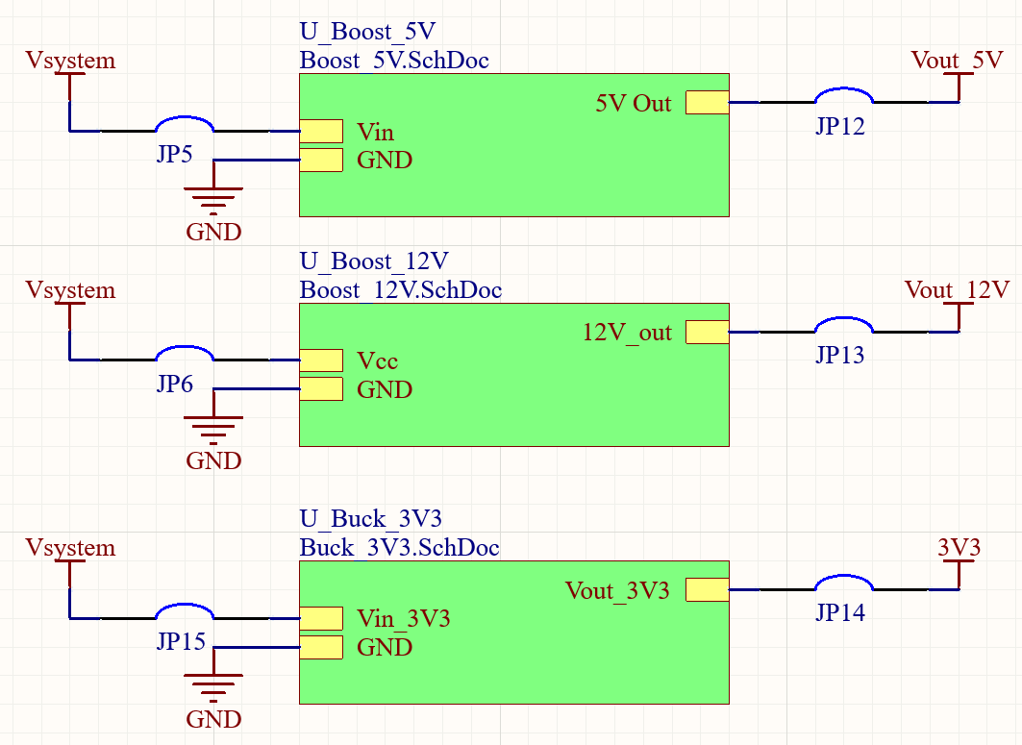

For this same example, I would also solder wires to the following nets for inspection with the oscilloscope:

1. Ground
2. Vsystem / OUT pins from BQ24075
3. Vout_5V
4. Vout_12V
5. 3V3

Since my example device has a 3.3V buck, 5V boost, and 12V boost, I would provide a total of six oscilloscope captures with the following information:

1. 3.3V startup transient
2. 3.3V steady state
   1. Average voltage
   2. Error between expected and actual voltage
   3. Min voltage
   4. Max voltage
   5. Voltage ripple as a percentage of the output voltage
3. 5V startup transient
4. 5V steady state
   1. Average voltage
   2. Error between expected and actual voltage
   3. Min voltage
   4. Max voltage
   5. Voltage ripple as a percentage of the output voltage
5. 12V startup transient
6. 12V steady state
   1. Average voltage
   2. Error between expected and actual voltage
   3. Min voltage
   4. Max voltage
   5. Voltage ripple as a percentage of the output voltage

**Note: If you have a non-standard power mode (such as an externally supplied voltage), discuss your requirements with the teaching team.**

If your design does not work as expected, please get in touch with the teaching team. It is quite simple to damage your design, so we’d like to help you write and execute a rework plan to get things functioning as expected.

**Submission:**

* Submit photos of your PCBA soldered with voltage test wires.
* Submit your labeled oscilloscope captures and voltage calculations.
* Do a brief write-up with your results
  + Was everything within specification or did you see any failures?

### 2.3 Load Testing

Next, we’ll load test your riskiest regulation circuit. **You do not need to do load testing on all of your power regulation circuits!** Only the one that is the highest risk. For example, if I have a 3.3V buck or a 12V boost, I would be more concerned about the large change in voltage required for the 12V boost.

Review the **Getting Started with the E-Load** PDF in the A12 assignment folder. This PDF explains how E-Loads (electronic loads) work, why we use them, and how to use the e-loads in the Detkin Lab. Please note that there are limited E-loads in the Detkin lab and they must be shared.

For your chosen regulation circuit, review your expected current load. Then, use the E-Load to evaluate the following conditions: 10%, 50%, 100%, and 120% of the expected current load. The E-Load will be measuring the actual voltage with the applied load - this is what we want to log.

#### Example Load Testing

My 12V boost regulator is the riskiest regulator in my circuit. It needs to supply 500mA to drive a motor, but the regulator IC can supply up to 750mA. I will attach the DC power supply to the output of the BQ24075 at 4.0V (not quite a full LiPo). I will attach the E-Load to the motor connector. Then, I will evaluate 10%, 50%, 100%, and 120% loads using the E-Load and write down the corresponding voltages in a table.

| Expected Load | Voltage |
| --- | --- |
| 10% (50mA) | 12.12V |
| 50% (250mA) | 11.98V |
| 100% (500mA) | 11.67V |
| 120% (600mA) | 11.45V |

**Submission:**

* Photos of E-Load testing setup
* A table of expected load with the corresponding voltage as measured by the E-Load.
* List any issues encountered.

### 2.4 Thermal Image

With your device under load, take an image using the thermal camera from the Detkin lab.

**Note: This is an example image showing you how to use the thermal camera. Please take a photo using the TG165-X Thermal Camera, then offload the image from its SD card.**

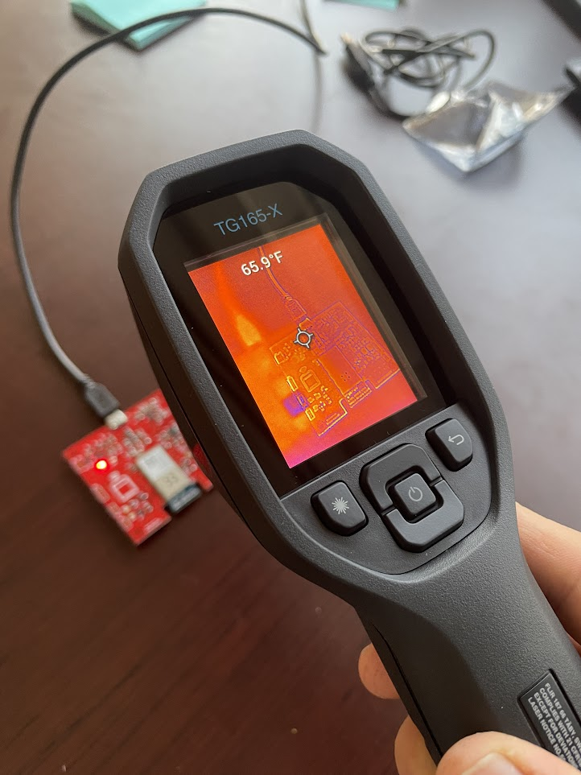

**Submission:**

* Submit a thermal image of your device running under load.
* Write what load the PCBA circuit was running under.

# 3. Programming

Connect your programmer to your custom PCBA. Note that the programmer **does not** supply power to the PCBA - you’ll need to power the PCBA separately.

If using the Segger J-Link, you can reference this: [J-Link Interface Description](https://www.segger.com/products/debug-probes/j-link/technology/interface-description/#swd-and-swo-also-called-swv-compatibility)

* J-Link drivers live here: <https://www.segger.com/downloads/jlink/>

If using the Atmel-ICE, you can reference this: [Atmel-ICE User Guide](https://www.digikey.com/en/resources/datasheets/atmel/atmel-ice-user-guide)

Within Microchip Studio, find and click the **Device Programming** button. Select your **Tool** with the interface **SWD**, then hit **Apply**. Read both the **Device signature** and **Target voltage**. Then, try flashing code to the microcontroller.

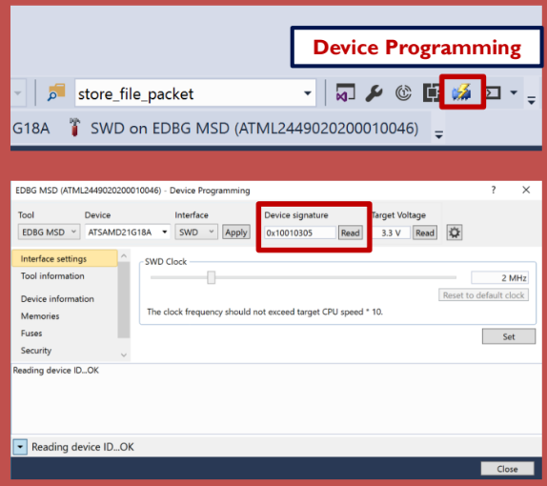

**Submission:**

* Submit a photo of your programmer attached to the PCBA.
* Submit a screenshot of your device signature and target voltage from the device programming window.
* List any issues encountered.

# 4. Peripheral Evaluation

Now that you can program your PCBA, it is time to start bringing up the peripherals in your system. Typically, these systems are brought online one by one. For each of these following steps, you may run into failures. Review your firmware and Altium hardware files to try to find issues. Use the debugging tools in the lab to check for voltage, analyze serial communication, etc. The teaching team will also be around to help.

### 4.1 Debug LED

Write or leverage existing firmware that turns on your debugging LED on the PCBA. Remember, this is your custom PCBA, so it might be a different pin than the SAM W25 Xplained Dev Board debug LED!

Toggle the LED state every 1000ms to show control over the LED.

### 4.2 Debug Button

Write or leverage existing firmware that handles the debug button on your PCBA. Remember, this is your custom PCBA, so it might be a different pin than the SAM W25 Xplained Dev Board debug button!

Write firmware logic so that the debug LED turns on when the debug button is pressed down. When the debug button is not pressed, the debug LED should turn off.

### 4.3 UART Communication

Flash your existing CLI code to demonstrate that the UART communication system is working.

### 4.4 Non-volatile Memory (SD Card)

Write or leverage existing firmware that writes a file to the SD card.

### 4.5 I2C Device

Write or leverage existing firmware that interfaces with your I2C device (as in A08 I2C Drivers).

**Submission:**

* Submit videos / GIFs of your peripherals working on your PCBA.
* List any issues encountered.

# 

# Rubric

While the rubric attempts to capture all assignments details, points assigned may vary based on submission quality and teaching team review. Please ensure you read the assignment carefully so as not to miss details and lose points. Poor readability / formatting can lose you points on any assignment.

**For all questions, 0 points will be awarded if the submission is non-existent, very poorly done, or doesn’t compile (for firmware assignments).**

| **Max Points** | **Question** | **How to achieve full credit** |
| --- | --- | --- |
| 5 | 1. Visual Board Inspection & Photograph | PCBAs are reviewed in a detailed manner and photographed nicely, such that there is appropriate lighting and details can be made out. Any issues were reported. |
| 45 | 2. Power System Evaluation | The detailed power system evaluation instructions were followed and documented. Any issues in the power system were reported. |
| 5 | 3. Programming | The MCU was programmed successfully. Any issues were reported. |
| 15 | 4. Peripheral Evaluation | Each peripheral was documented in the board bringup process. Any issues were reported. |
| 70 |  | Total Achievable Points |